H E L W A N U N I V E R S I T Y
F a c u l t y o f
C o m p u t e r s a n d A r t i f i c i a l I n t e l l i g e n c e

Nextronica
A graduation project dissertation by:

Eslam Sabry Rabea Rizk | ( 20210156 )
Mohamed Sayed Abdulaziz | ( 20210785 )
Jana Mohamed Aly Mourad | ( 20210257 )
Mostafa Abdelfattah | ( 20210937 )
Halima Ramadan Salah Sayed | ( 20210295 )

Submitted in partial fulfilment of the requirements for the degree of Bachelor of Science in Computers & Artificial Intelligence, the Faculty of Computers & Artificial Intelligence, Helwan University

Supervised by:

Dr. Mohamed Marie

July 2025

ACKNOWLEDGEMENT

First and foremost, we would express our deepest gratitude and appreciation to our supervisor Dr. Mohamed Marie for outstanding guidance, their continuous support and help as they were always here for us providing more than the needed time and effort from them since the very beginning of our project.

We would also like to thank our families, especially our parents, for their encouragement, patience, and assistance over the years. We are forever indebted to our parents, who have always kept us in their prayers and pushed us to Success.

Finally, for our faculty for providing the suitable environment that leaded us to represent the best image that computer science graduates of Helwan University are supposed to represent.



Table of Contents
Chapter 1: Introduction
  - Overview 7
  - Objectives 8
  - Purpose 9
  - Scope 9
  - General Constraints 10
Chapter 2: Project “Planning and analysis”
  - Project planning
    - Feasibility Study 11
    - Gantt Char 15
  - Analysis and Limitation of existing system 17
  - Need for the new system 17.
  - Analysis of the new system
    - User requirements 18
    - System Requirements 19
    - Domain Requirements 20
    - Functional Requirements 21
    - Non- Functional Requirements 23
  - Advantages of the new system 24
  - Risk and Risk Managements 25



Chapter 3: Software Design
  - Design of database (ERD or Class) Diagram 27
  - Use case diagram 28
  - sequence diagram 32
  - activity diagram 43
Chapter 4: Implementation
4.1 Software architecture 44
Chapter 5: Testing
  - Unit Testing 54
  - Integrated testing 55
  - Additional Testing 57
Chapter 6: Results and Discussion
  - Results
    - Expected results 64
    - Actual results 65
  - Discussion 66
Chapter 7: Conclusion 67
Chapter 8: Future work 68

Chapter 1

Introduction

Overview
The project is a web-based e-commerce platform for electronics, built with React and Spring Boot, tailored for Egyptian consumers and local vendors. It offers an extensive bilingual catalog (Arabic and English) across categories like Consumer Electronics, Home Appliances, and Smart Devices. Key features include advanced search, personalized recommendations, real-time inventory tracking.

For vendors, it provides an easy onboarding process, performance analytics, marketing tools, and fair commission structures, empowering small businesses.
The platform’s microservices-based, cloud-native architecture ensures scalability, 99.99% uptime, sub-second response times, and robust security, including end-to-end encryption and fraud detection. This project aims to modernize e-commerce in Egypt, enhancing user experience while supporting local innovation.

Objectives

Develop a Comprehensive Online Marketplace for Electronic Products Catalog Scope:
      - Extensive range of electronic categories
        - Consumer Electronics
        - Home Appliances
        - Computer Components
        - Smart Home Devices
        - Gaming Accessories

Key Features:
      - Sophisticated product classification
      - Detailed product information
      - Comparison tools
      - Bilingual platform (Arabic and English)

Provide a Seamless Shopping Experience for Egyptian Consumers User Experience Goals:
      - Intuitive, mobile-responsive design
      - Frictionless purchasing process
      - Localized payment solutions
      - Personalized user interfaces

Technology Enhancements:
      - Advanced search capabilities
      - Real-time inventory tracking
      - Multiple payment methods
      - Easy return processes

Support Local Electronics Vendors and Businesses Vendor Empowerment:
      - Low-entry barrier for local sellers
      - Comprehensive onboarding program
      - Fair commission structures
      - Marketing and sales support
      - Performance analytics tools

Economic Impact:
      - Create opportunities for small electronics businesses.
• Reduce digital marketplace entry barriers.

      - Showcase local innovation.
      - Generate new revenue streams for entrepreneurs.

Implement a Robust and Scalable E-Commerce Solution Technical Architecture:
      - Microservices-based infrastructure
      - Cloud-native design
      - Horizontal scaling capabilities
      - Advanced security protocols

Performance Targets:
      - 99.99% system uptime
      - Sub-second response times
      - Robust error handling
      - Continuous system optimization

Security Priorities:
      - End-to-end encryption
      - Compliance with local data regulations
      - Advanced fraud detection
      - Regular security audits

Scope
The Nextronica platform will encompass:

- User-friendly web application for customers

- Administrative control panel

- Comprehensive product catalog

- Secure payment and order processing

- Customer support and review mechanisms

General Constraints

- Web-Based Application: Use scalable, responsive, and modular technologies like React and Spring Boot.

- Browser Compatibility: Optimize for modern browsers (Chrome, Firefox, Edge, Safari) with backward compatibility for recent versions.
- Robust Security: Ensure HTTPS, role-based access, encryption, fraud detection, and regular audits.

- Multilingual Support: Provide Arabic (RTL) and English with seamless switching and culturally relevant translations.
- Regulatory Compliance: Adhere to Egyptian e-commerce laws, including data privacy, VAT, approved payment gateways, and clear return policies.

Chapter 2

Project “Planning & Analysis”

Project Planning

Feasibility Study

Problem Statement

The Egyptian electronics market faces significant challenges in providing accessible, reliable,
and comprehensive online shopping experiences. Existing platforms suffer from:
      - Limited product variety
      - Lack of support for local vendors
      - Inefficient purchasing processes
      - Inadequate customer support
      - Limited digital marketplace options for Egyptian consumers
Nextronica aims to address these challenges by creating a comprehensive, user- friendly e-commerce platform that serves the unique needs of the Egyptian electronics market.

Cost Analysis

Initial Development Costs

- Software Development
  - Backend Development: 150,000 EGP
  - Frontend Development: 100,000 EGP
  - Mobile App Development: 80,000 EGP
  - Total Software Development: 330,000 EGP

Infrastructure
  - Cloud Hosting (Annual): 60,000 EGP
  - Server Setup: 40,000 EGP
  - Network Security: 25,000 EGP
  - Total Infrastructure: 125,000 EGP

Design and User Experience
  - UI/UX Design: 50,000 EGP
  - Branding: 30,000 EGP
  - Total Design Costs: 80,000 EGP

Marketing and Launch
  - Initial Marketing Campaign: 100,000 EGP
  - Social Media Advertising: 50,000 EGP
  - Content Creation: 30,000 EGP
  - Total Marketing: 180,000 EGP

Operational Costs (Annua l)

Human Resources
  - Technical Team Salaries: 600,000 EGP
  - Customer Support: 240,000 EGP
  - Management: 300,000 EGP
  - Total HR Costs: 1,140,000 EGP

Ongoing Technical Expenses
  - Cloud Hosting: 72,000 EGP
  - Software Maintenance: 100,000 EGP
  - Security Updates: 50,000 EGP
  - Total Technical Expenses: 222,000 EGP

Revenue Projection

Revenue Streams
  - Vendor Commission (15%): Estimated 500,000 EGP/year
  - Advertising Revenue: 100,000 EGP/year
  - Total Estimated Revenue: 600,000 EGP/year

Cos t Summary

  - Total Initial Investment: 715,000 EGP
  - Annual Operational Costs: 1,362,000 EGP
  - Estimated Annual Revenue: 750,000 EGP

Cost Benefits

  - Reduced overhead compared to physical retail.
  - No warehouse maintenance costs.
  - Minimal physical infrastructure requirements
  - Scalable business model
  - Low entry barrier for vendors

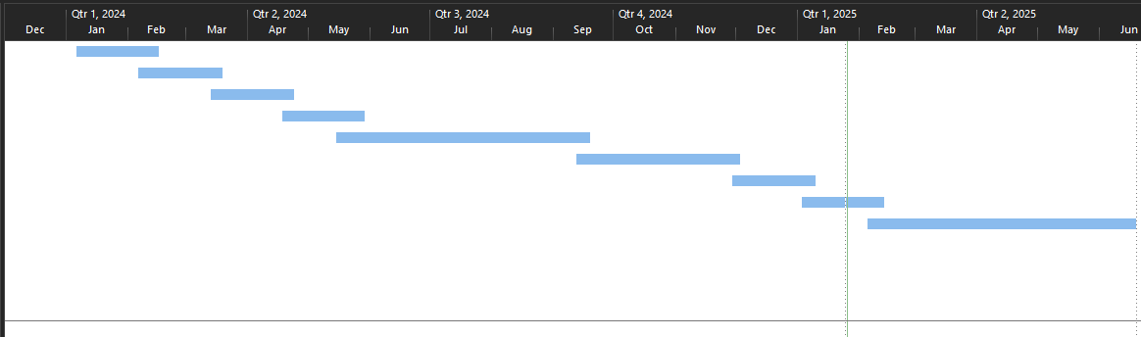
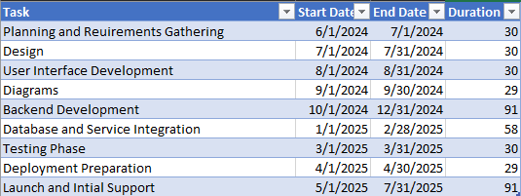
    - Gantt Chart

    - System Design & Functional Requirements

  - Class Diagram

  - Use Case Diagrams

User Use Case Diagram
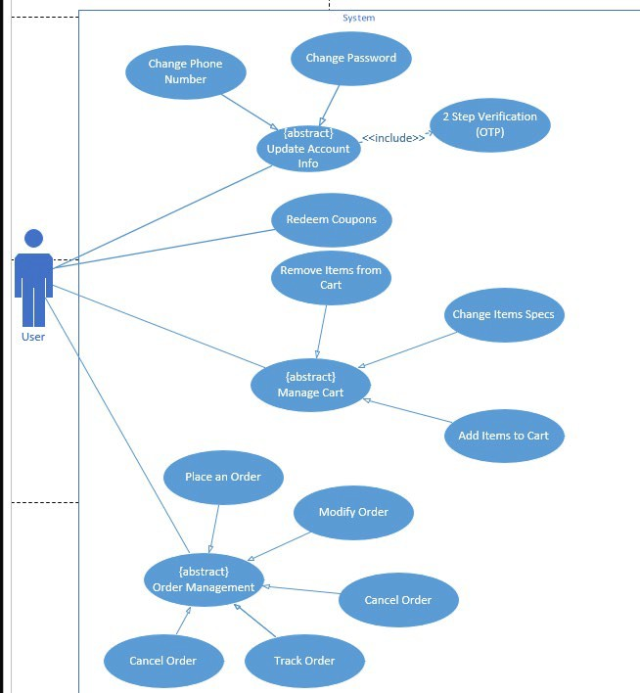

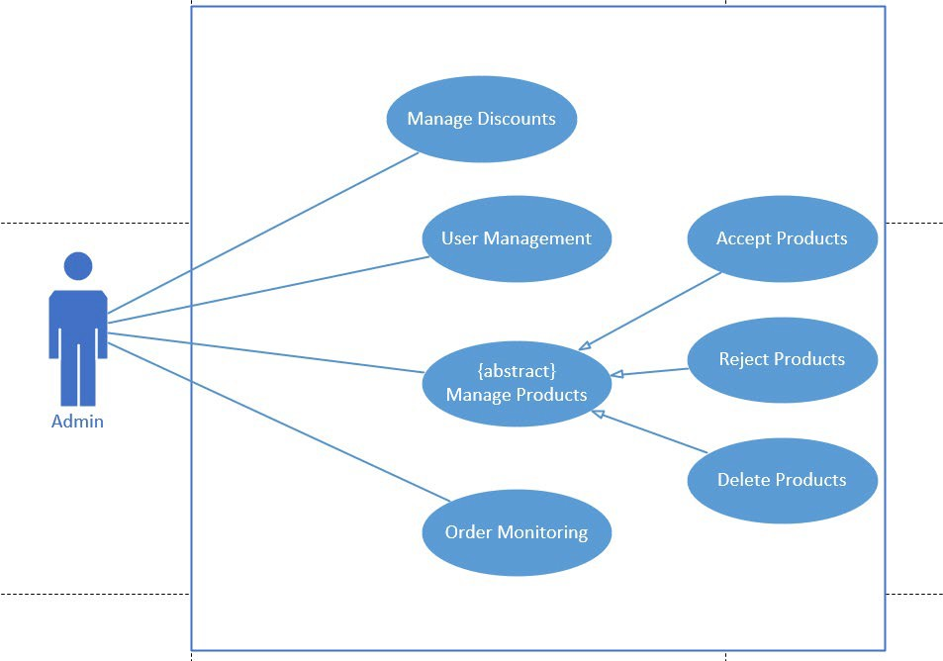
Admin Use Case Diagram

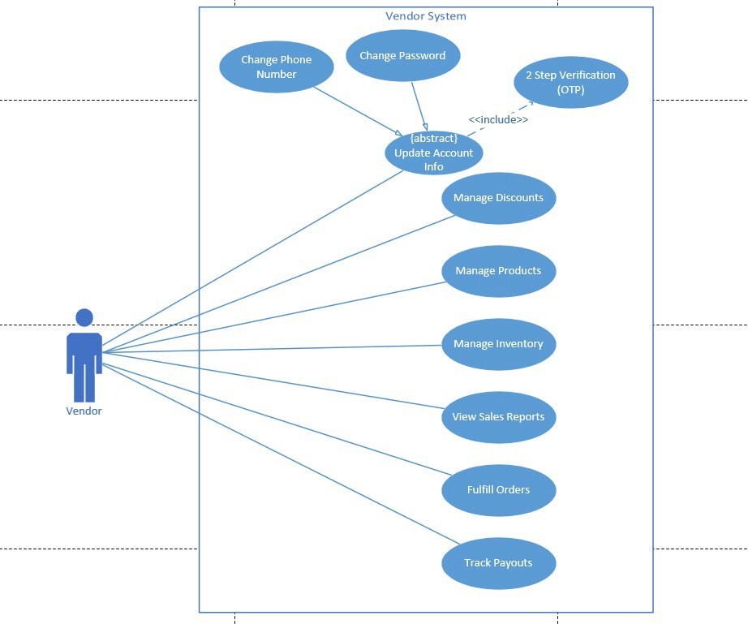
Vendor Use Case Diagram

Guest Use Case Diagram

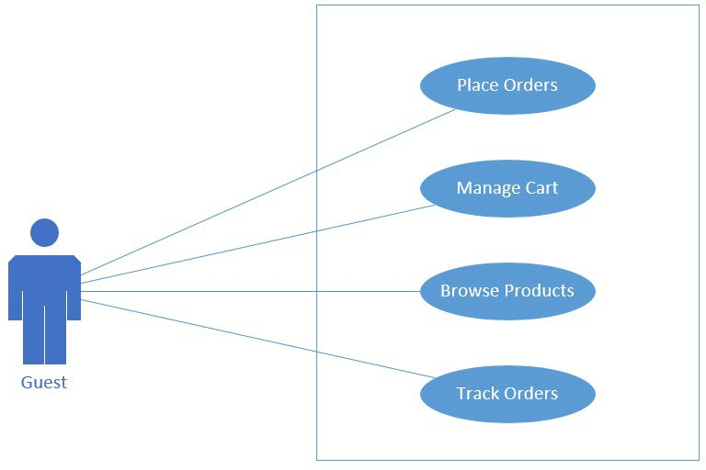

Sign Up

Use Case Title | Signup with Email Confirmation and Phone Number Verification
Use Case ID | UC-001
Actor | A new user who wants to register for the service
Goal | To successfully register a new user by collecting their email and phone number,  confirming the email address, and verifying the phone number.
Pre-conditions | - The user must have access to a valid email address and phone number.  - The user must have internet access.  - The signup page must be accessible and functioning.
Post-conditions | - The user is successfully registered and has an active account.  - The email and phone number are verified.  - The user receives confirmation notifications for both the email and phone number.
Exceptions | - If the email is already registered, display an error message.  - If the phone number is already verified or registered, display an error message.  - If the phone number verification code is incorrect or expired, prompt the user to request a new code.
Main Flow | User  - User Accesses Signup Page. | System  - System Displays Signup Page.  - System Validates User Information.  - System Sends Email Confirmation.  - System Sends Phone Verification Code.  - System Verifies Email Confirmation.  - System Verifies Phone Verification Code.  - System Redirects User to Welcome Page.
 | 2- User Enters Details.
 | 3- Submit Signup Form.
 | 4- User Checks Email.
 | 5- User Enters Phone Verification Code
 | 6- Signup Complete.

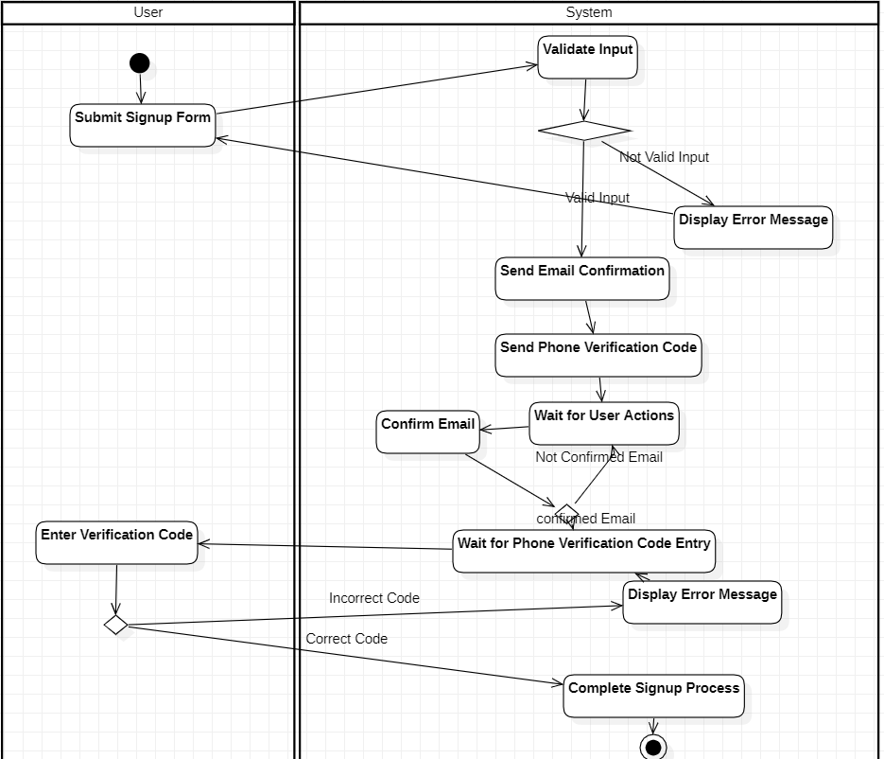
Activity Diagram

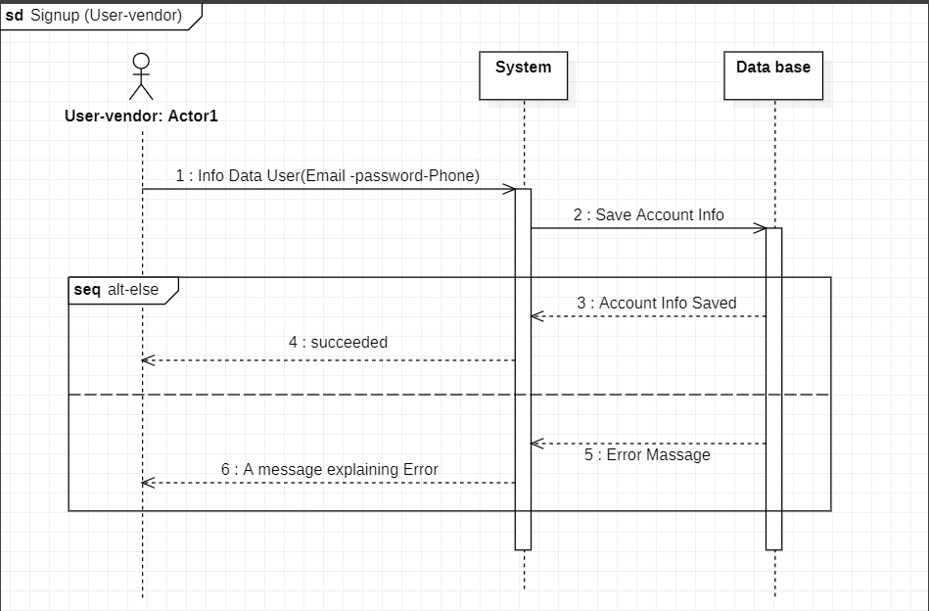
Sequence Diagram

Login

Use Case Title | Login
Use Case ID | UC-002
Actor | User: An existing user who wants to access their account.
Goal | To allow an existing user to securely log in to their account using their email and password.
Pre-conditions | The user must have a registered account with a valid email and password.
Post-conditions | - The user is successfully logged in and redirected to their account dashboard.  - The user session is initiated for the duration of the login.
Exceptions | - If the email is not registered, display an error message.  - If the password is incorrect, display an error message.  - If the account is locked or suspended, display an error  message.
Alternative Flow | *Alternative Flow for Incorrect Password, Email:  - 4A. The system detects that the Credentials are incorrect.  - 4B. The system displays an error message and allows the user to retry.  *Alternative Flow for Locked Account:  - 4C. The system detects that the account is locked or suspended.  - 4D. The system displays an error message informing the  user of the account status.
Main Flow | User  - User Accesses Login Page.  - User Enters Credentials.  - Submit Login Form. 4-Successful Login.  5-Login Complete. | System  - System Displays Login Page.  - System Validates Credentials.  - System Creates User Session.  - System Redirects User.  - System Displays Welcome Dashboard

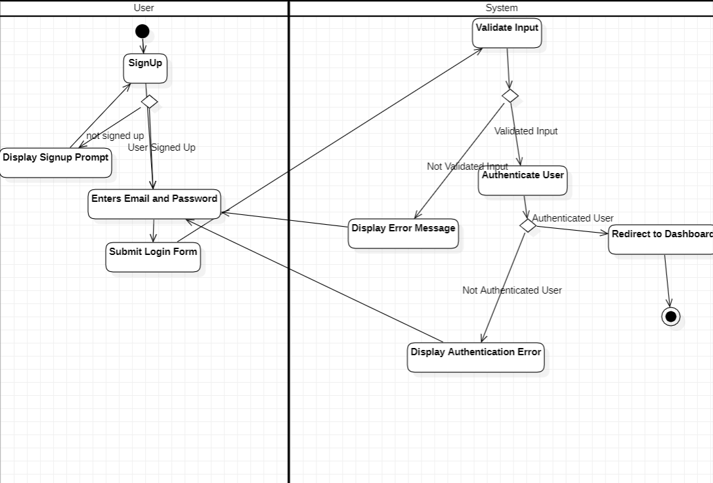
Activity Diagram

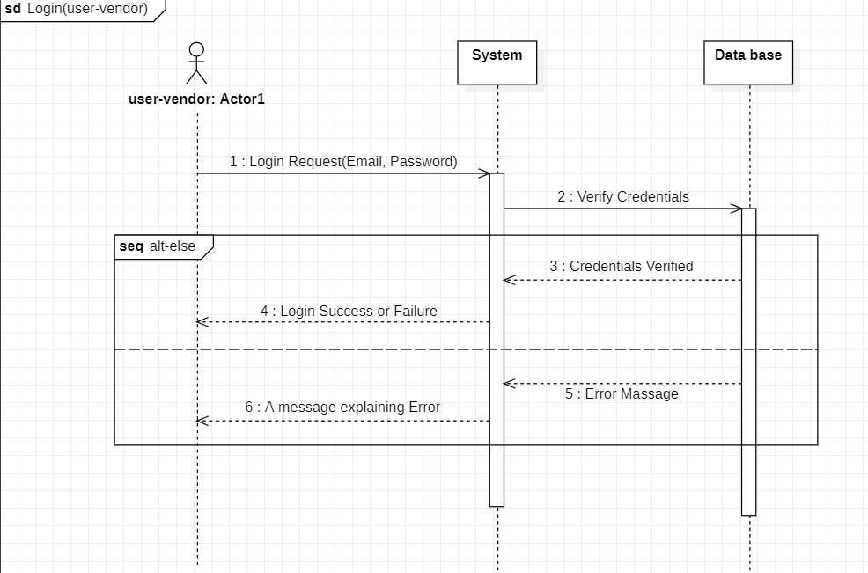
Sequence Diagram

Change Password

Use Case Title | Change Password
Use Case ID | UC-003
Actor | User: An authenticated user who wants to change their password.
Goal | To enable the user to securely change their account password.
Pre-conditions | - The user must be logged into their account.  - The user must know their current password.  - The user must have access to the password change page.
Post-conditions | - The user’s password is successfully updated.  - The user can log in with the new password.
Exceptions | - If the current password entered is incorrect, display an error message.  - If the new password does not meet security requirements (e.g., length, complexity), display an error message.  - If there’s a system error while processing the password change, notify the user.
Alternative Flow | *Alternative Flow for Incorrect Current Password:  - 5A. The system detects that the current password is incorrect.  - 5B. The system displays an error message and allows the user to retry.  *Alternative Flow for Invalid New Password:  - 6A. The system detects that the new password does not meet security requirements.  - 6B. The system displays an error message explaining the requirements.
Main Flow | User  - User Accesses Change Password Page.  - User Enters Current Password.  - User Enters New Password.  - Submit Password Change Form:  - Logout Prompt. | System  - System Displays Change Password Page:  - System Validates Current Password.  - System Validates New Password.  - System Updates Password.  - System Sends  Confirmation.

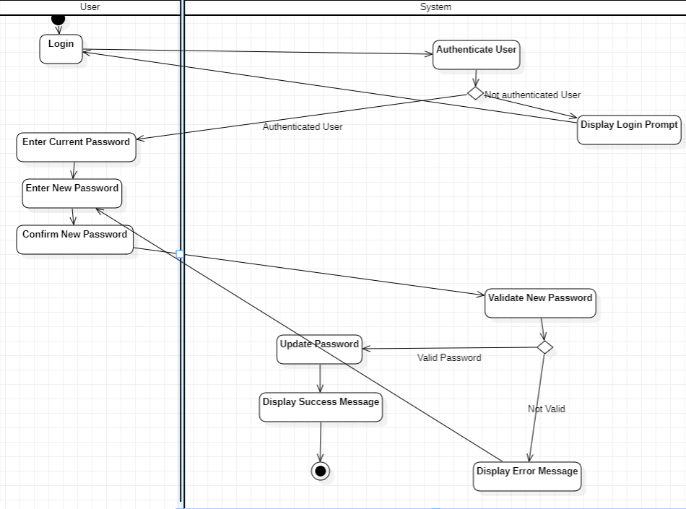
Activity Diagram

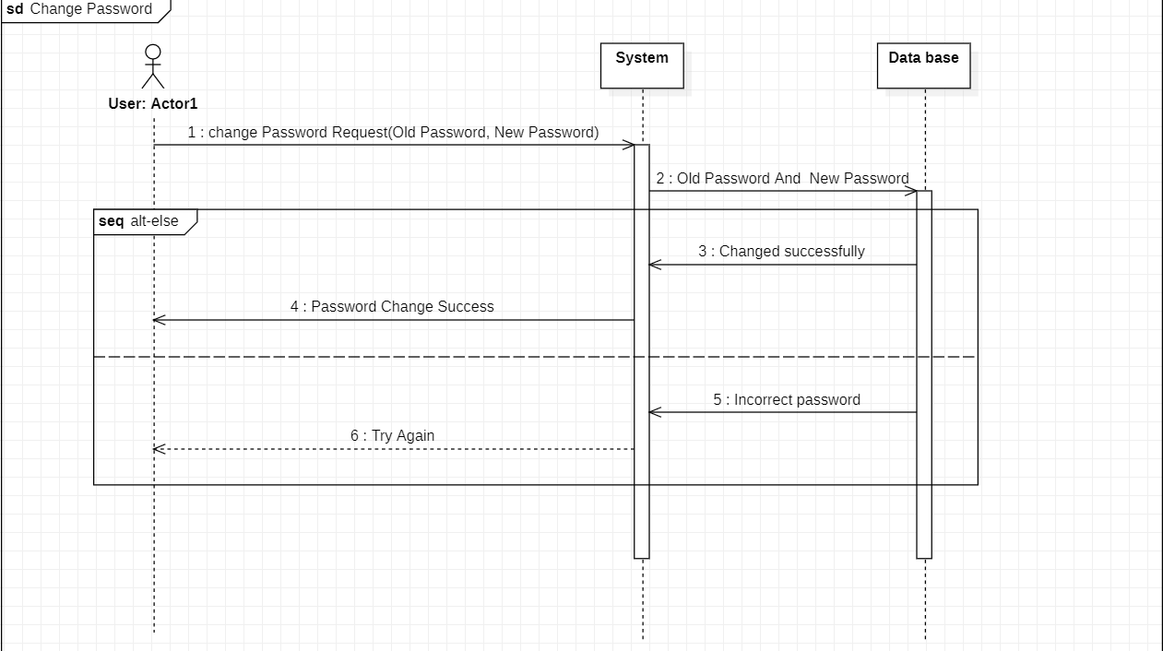
Sequence Diagram

Forgot Password

Use Case Title | Forget Password
Use Case ID | UC-004
Actor | User: A user who has forgotten their account password and wants to reset it.
Goal | To allow the user to securely reset their password using their registered email address.
Pre-conditions | - The user must have a registered account with a valid email address.  - The user must have access to the email account.
Post-conditions | - The user receives a password reset link via email.  - The user can successfully reset their password.
Exceptions | - If the email sending fails due to a system error, notify the user.  - If the reset link is expired or invalid, prompt the user to request a new link.
Alternative Flow | *Alternative Flow for Email Sending Failure:  - 5A. The system encounters an error while trying to send the email.  - 5B. The system displays an error message and suggests the user try again later.  *Alternative Flow for Expired or Invalid Reset Link:  - 6A. The user clicks on an expired or invalid reset link.  - 6B. The system displays an error message and prompts the user to request a new password reset link.
Main Flow | User  - User Accesses Forgot Password Page:  - User Enters Email Address:  - Submit Request:  - User Checks Email:  - User Enters New Password:  - Submit New Password. | System  - System Displays Forgot Password Page:  - System Validates Email:  - System Generates Password Reset Link (If Email is Registered):  - System Sends Password Reset Link:  - System Redirects to Password Reset Page:  - System Validates New Password:  - System Updates Password:  - System Sends Confirmation:

Activity Diagram

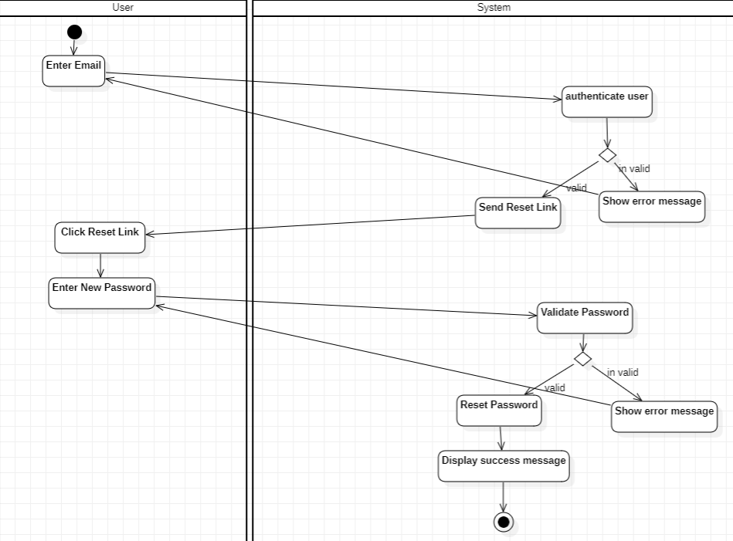

Sequence Diagram

Change Phone Number

Use Case Title | Change Phone Number
Use Case ID | UC-005
Actor | User: An authenticated user who wants to change their registered phone number.
Goal | To enable the user to securely change their registered phone number.
Pre-conditions | - The user must be logged into their account.  - The user must have access to their current phone number.  - The user must have access to the new phone number they wish to use.
Post-conditions | - The user’s phone number is successfully updated.  - The user receives a confirmation notification via SMS to their new phone number.
Exceptions | - If the new phone number is already in use by another account, display an error message.  - If the user fails to verify the new phone number within a specified time, prompt them to request a new verification code.
Alternative Flow | *Alternative Flow for New Phone Number Already in Use:  - 6A. The system detects that the new phone number is already associated with another account.  - 6B. The system displays an error message prompting the user to choose a different phone number.  *Alternative Flow for Verification Code Expiration:  - 9A. The user does not enter the verification code within the specified time frame.  - 9B. The system displays a message indicating that the code has expired and provides an option to resend the verification code.
Main Flow | User  - User Accesses Change Phone Number Page.  - User Enters Current Phone Number  - User Enters New Phone Number.  - Submit Change Phone Number Form.  - User Receives SMS Code.  - User Enters Verification Code. | System  - System Displays Change Phone Number Page.  - System Validates Current Phone Number.  - System Validates New Phone Number.  - System Sends Verification Code.  - System Validates Verification Code.  - System Updates Phone Number.  - System Sends Confirmation.

Activity Diagram

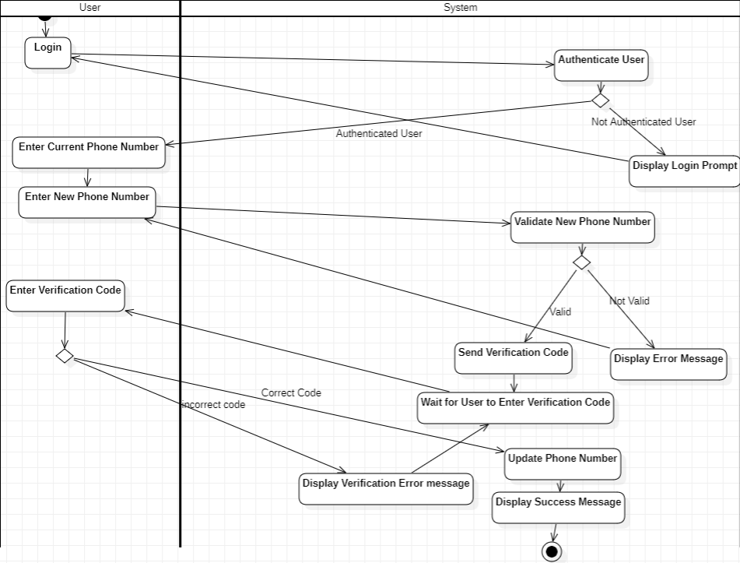

Sequence Diagram

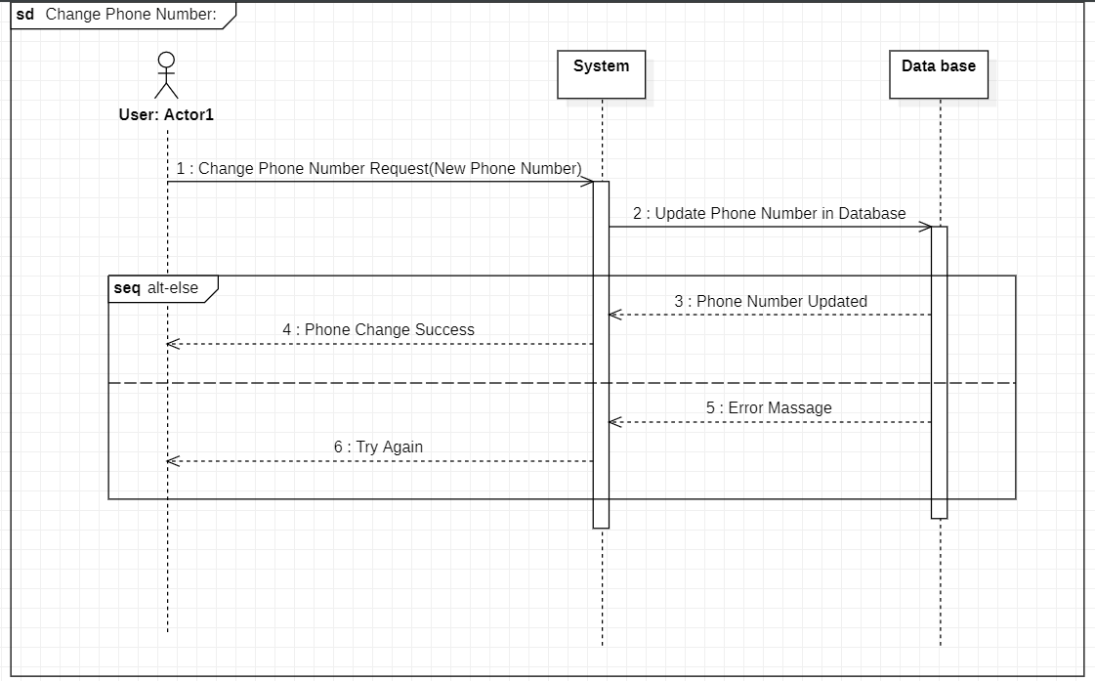

Manage Cart

Title | Manage Cart
Actors | customer who is shopping on the e-commerce site.
Goal | To allow customers to add, remove, update quantities, and view items in their shopping  cart
Preconditions | - The customer must be logged into their account .  - The customer has items in their cart.
Postconditions | The cart is updated based on the customer's actions (items added, removed, or quantities updated)
Exceptions | - Out of Stock:  - If the customer attempts to add an item that is out of stock, the system displays an error message.  - Invalid Quantity:  - If the customer tries to update the quantity to a negative number or exceeds available stock, the system displays an error message.
Alternative Flows | Empty Cart:  If the cart is empty, the system displays a message indicating that the cart is empty and provides a link to continue shopping.
Flow of Activity | Actor  - View Cart:  The customer clicks on the Cart icon to view current items in the cart.  - Add Item to Cart:  - The customer browses products and selects an item to add to the cart.  - The customer clicks "Add to Cart."  - Remove Item from Cart: 1-the customer identifies an item they want to remove.  2-The customer clicks "Remove" next to the item.  4-Update Item.  5-Proceed to Checkout. | System  - The system displays the current items in the cart  - showing details such as item names, quantities, prices, and total cost.  - The system adds the item to the cart and  - updates the total cost.  - confirmation message displayed.  - The system adds the item to the cart and  - updates the total cost.  - confirmation message displayed.  - The system updates the items  - The system redirects the customer to the checkout process.

Activity Diagram

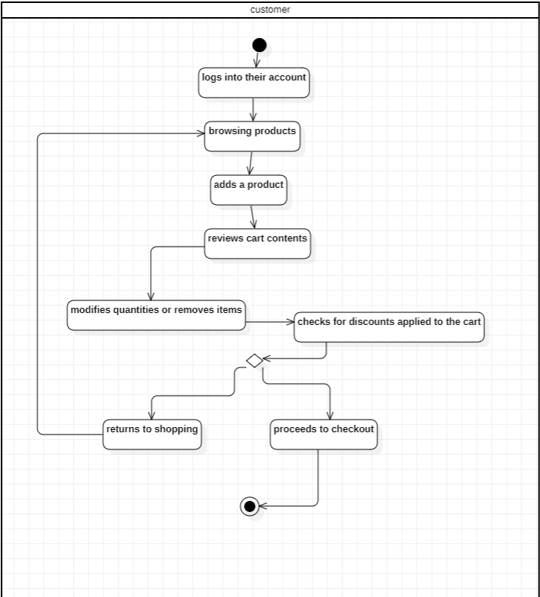

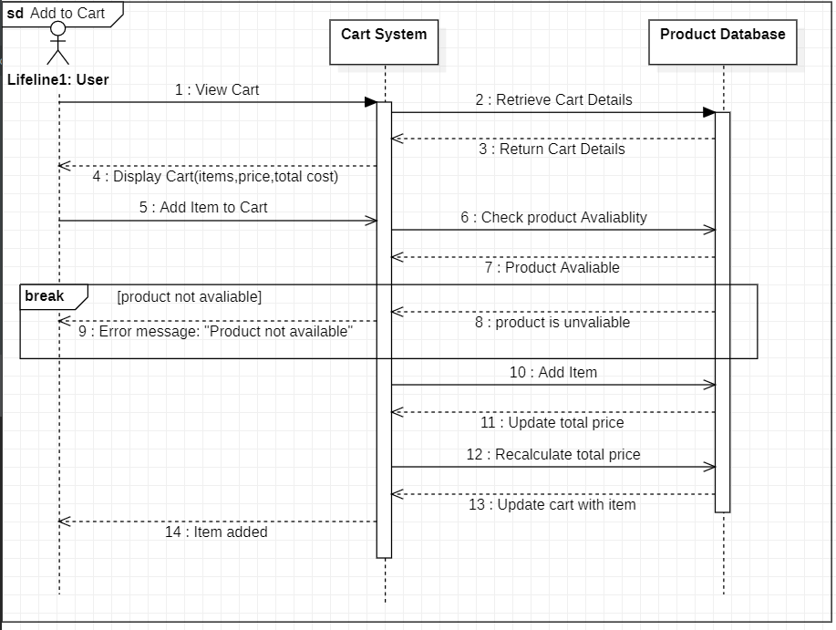
Sequence Diagram



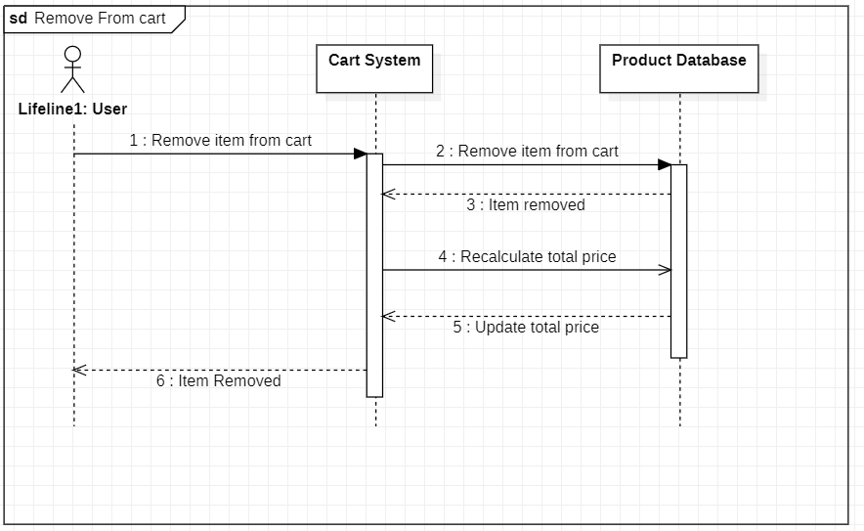



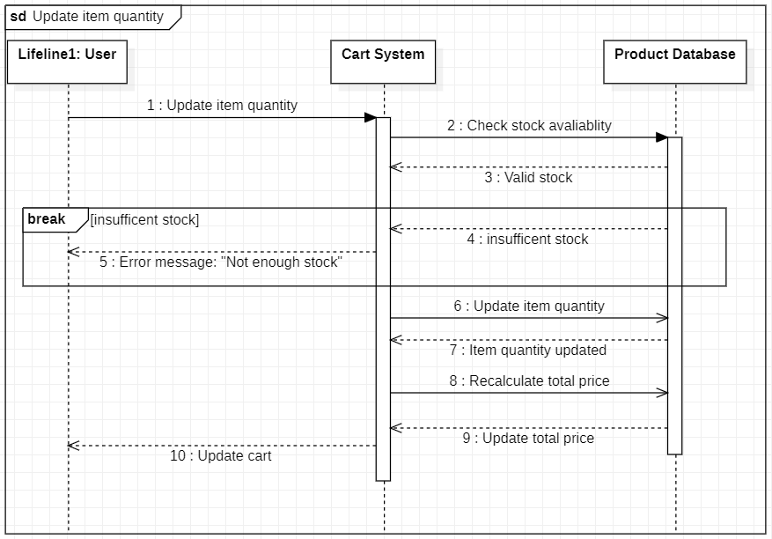

  - Choose Shipping Method

Title | Choose Shipping Method
Actors | Customer: The user who is purchasing items on the e-commerce site.
Goal | To allow customers to select their preferred shipping method during the checkout process.
Preconditions | The customer has items in their cart and has initiated the checkout process.
Postconditions | The selected shipping method is saved and used for order processing.
Exceptions | Error Retrieving Shipping Methods:  - If the system encounters an error when retrieving available shipping methods, it displays an error message and suggests trying again.
Alternative Flows | No Shipping Options Available:  If no shipping methods are available for the customer’s location, the system displays a message indicating this and prompts the customer to contact support.
Flow of Activity | Actor  - Access Shipping Options:  The customer reaches the "Shipping Method" section  - View Shipping Details:  Each shipping option includes relevant details  - Select Shipping Method:  - The customer reviews the available options and selects their preferred shipping method.  - The customer clicks on the "Select" button next to their choice.  4-Confirm Selection: | System  1.1The system displays available shipping methods  4.1The system updates the order summary to reflect the chosen shipping

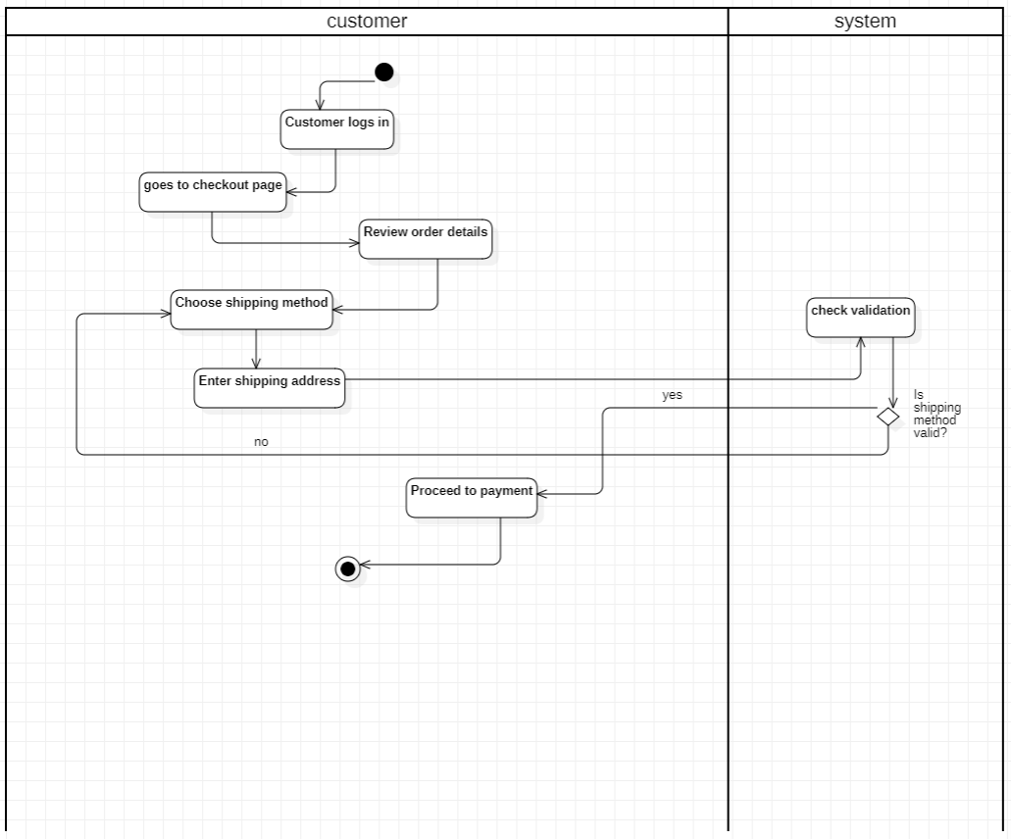
Activity Diagram

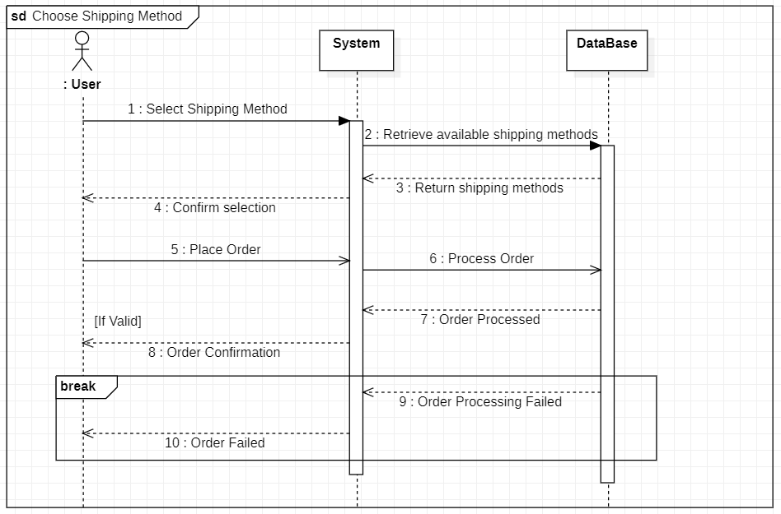
Sequence Diagram

  - Place an Order

Title | Place an Order
Actors | Customer: The user who is completing a purchase on the e-commerce site.
Goal | To allow customers to finalize their shopping experience by placing an order for items in their cart.
Preconditions | - The customer has items in their cart.  - The customer has selected a shipping method.  - The customer is logged into their account
Postconditions | The order is placed successfully, and the customer receives confirmation  of the order.
Exceptions | - Insufficient Stock:  If an item goes out of stock before the order is placed, the system informs the customer and may remove the item from the order.  - Technical Issues:  If the system encounters an error while processing the order, it displays a generic error message and suggests trying again later.
Alternative Flows | - Payment Declined:  - If the payment is declined, the system displays an error message.  - The customer can choose to enter a different payment method or retry the current method.  - Order Cancellation:  - After placing the order, if the customer wants to cancel it, they may be given the option to cancel the order within a specified timeframe.
Flow of Activity | Actor  - Access Checkout:  The customer navigates to the checkout page after managing their cart.  - Review Order Summary  - Enter Payment Information:  The customer is prompted to enter payment details  - Confirm Payment:  The customer reviews their payment details and clicks on "Place Order."  - Order Confirmation:  - End Transaction: | System  2.1The system displays an order summary  3.1The system may offer saved payment methods if the customer is logged in.  6.1The system updates inventory levels based on the items purchased

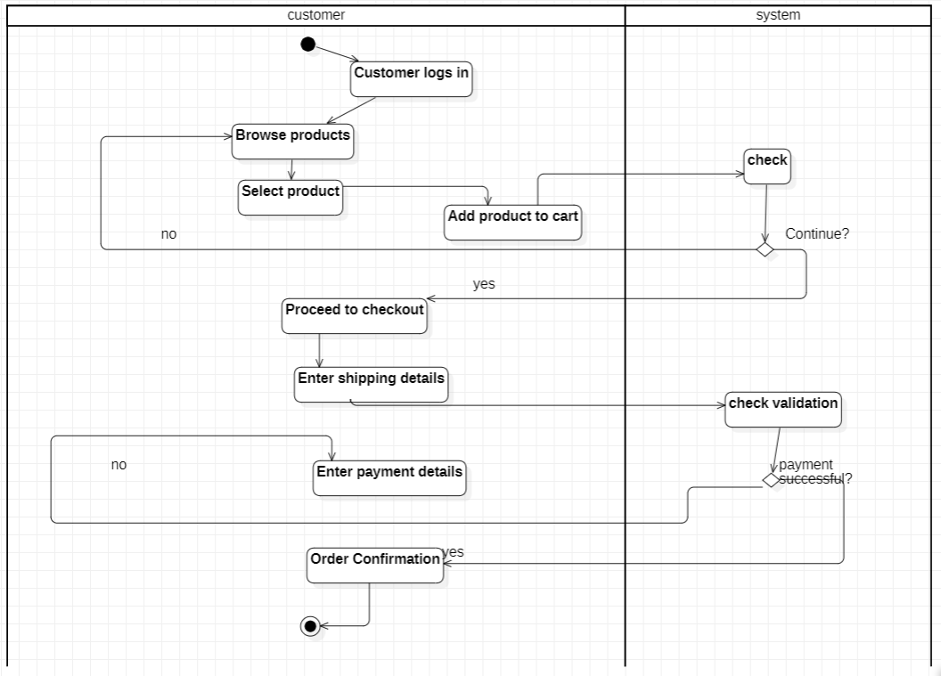
Activity Diagram


Sequence Diagram

  - Track Order Status

Title | Track Order Status
Actors | Customer: The user who wishes to monitor the status of their placed orders.
Goal | To enable customers to check the current status of their orders,  including shipping and delivery information.
Preconditions | - The customer has placed at least one order.  - The customer is logged into their account (if required).
Postconditions | The customer receives the current status of their order, including  any updates regarding shipping and delivery
Exceptions | Delayed Shipping:  - If there are unexpected delays in shipping, the system should notify the customer about the delay and provide updated estimates.
Alternative Flows | - Order Not Found:  - If the customer enters an incorrect order number or selects an order that doesn't exist, the system displays an error message.  - Technical Issues:  - If the system encounters an error retrieving order information, it displays a message prompting the customer to try again later.
Flow of Activity | Actor  - The customer navigates to the "Track Order" section on their account page.  - Select Order:  The customer selects the specific order they wish to track from a list of past orders.  - View Order Status:  - Receive Notifications  (optional):  The customer may opt to receive notifications via email updates on their order status. | System  3.1 The system displays the current status of the selected order.

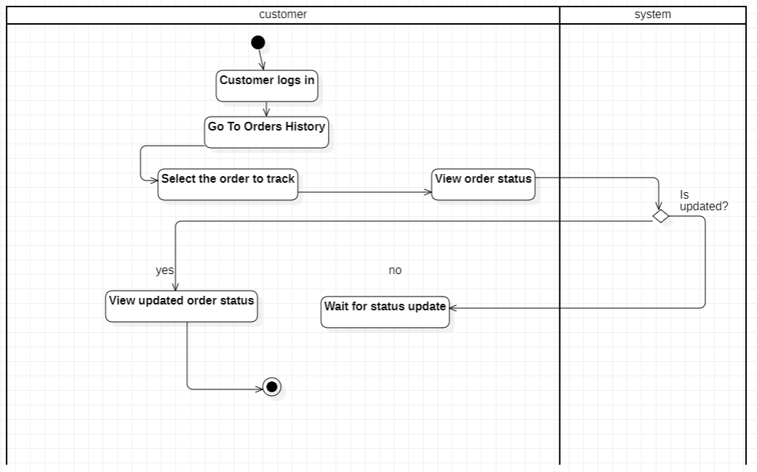
Activity Diagram

Sequence Diagram

  - Modify an Order

Title | Modify an Orde
Actors | Customer: The user who wishes to change details of an existing order.
Goal | To allow customers to make changes to their order, before the order  is finalized or shipped.
Preconditions | The customer has placed an order that is eligible for modification (the order has not yet been shipped).
Postconditions | The order is updated according to the customer's changes, and the  customer receives confirmation of the modifications.
Exceptions | - Insufficient Stock:  -If the customer attempts to increase the quantity of an item that is out of stock, the system notifies them and may suggest alternatives. 2-Payment Issues:  -If adding new items requires additional payment, the system prompts the customer to enter payment details.
Alternative Flows | - Modification Not Allowed:  - If the order is already in a state that doesn’t allow modifications (e.g., shipped or delivered), the system displays a message indicating that modifications are not possible.  - Error in Modification Process:  - If the system encounters an error while processing the modifications, it informs the customer and allows them to retry.
Flow of Activity | Actor  - Access Order History:  The customer logs into their account and navigates to the "Order History"  - Select Order to Modify:  The customer selects the specific order they wish to modify from the list of past orders.  - Initiate Modification: | System  4.1 The system displays the order details, allowing the customer to change  5.1 The system shows an updated order summary, including any changes made.  6.1 The system processes the changes and updates the  order in the database

 | The customer clicks on the "Modify Order" button  - Make Changes:  -The customer makes the desired changes.  - Review Changes  - Confirm Modification:  -The customer clicks on the "Confirm Changes" button. | 7.1The system provides a confirmation message detailing the modifications.
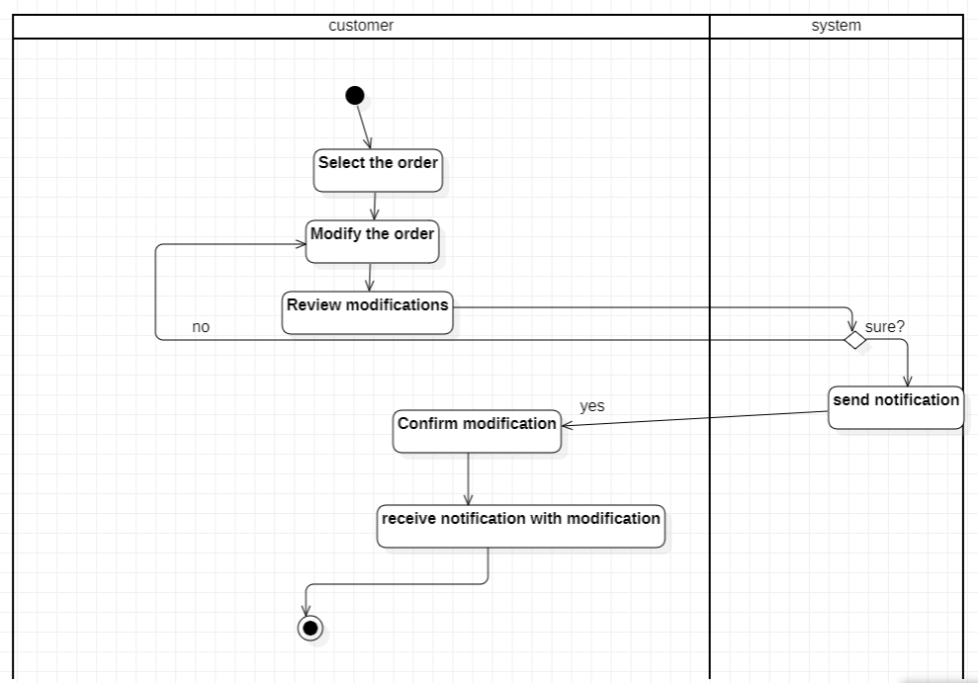
Activity Diagram

Sequence Diagram
  - Cancel an Order

Title | Cancel an Order
Actors | Customer: The user who wishes to cancel a previously placed order.
Goal | To allow customers to cancel their orders before they are processed, shipped, or delivered.
Preconditions | - The customer has placed an order.  - The order is still in a cancellable state (not yet shipped or delivered).
Postconditions | The order is canceled, and the customer receives confirmation of the  cancellation.
Exceptions | - Payment Issues:  - If the payment for the order was not successfully processed (e.g., declined card), the system notifies the customer and may not allow cancellation.  - System Maintenance:  - If the system is undergoing maintenance or is temporarily unavailable, the customer is informed and advised to try again later.
Alternative Flows | - Order Not Cancellable:  - If the order has already been shipped or delivered, the system informs the customer that the order cannot be canceled and may provide options for returns instead.  - Error in Cancellation Process:  - If there’s an error while processing the cancellation, the system displays a message informing the customer and allows them to retry.
Flow of Activity | Actor  - Access Order History:  The customer logs into their account and navigates to the "Order History"  - Select Order to Cancel: The customer selects the specific order they wish to cancel from the list of past orders.  - Initiate Cancellation: | System  - The system prompts the customer to confirm the cancellation, warning them about the implications.  - The system updates the order status to "Canceled" in the database.  - If applicable, the system initiates the refund process

 | The customer clicks on the "Cancel Order" button  - Confirm Cancellation:  The customer confirms their decision to cancel.  - Process Cancellation | 6.1The system displays a cancellation confirmation message.

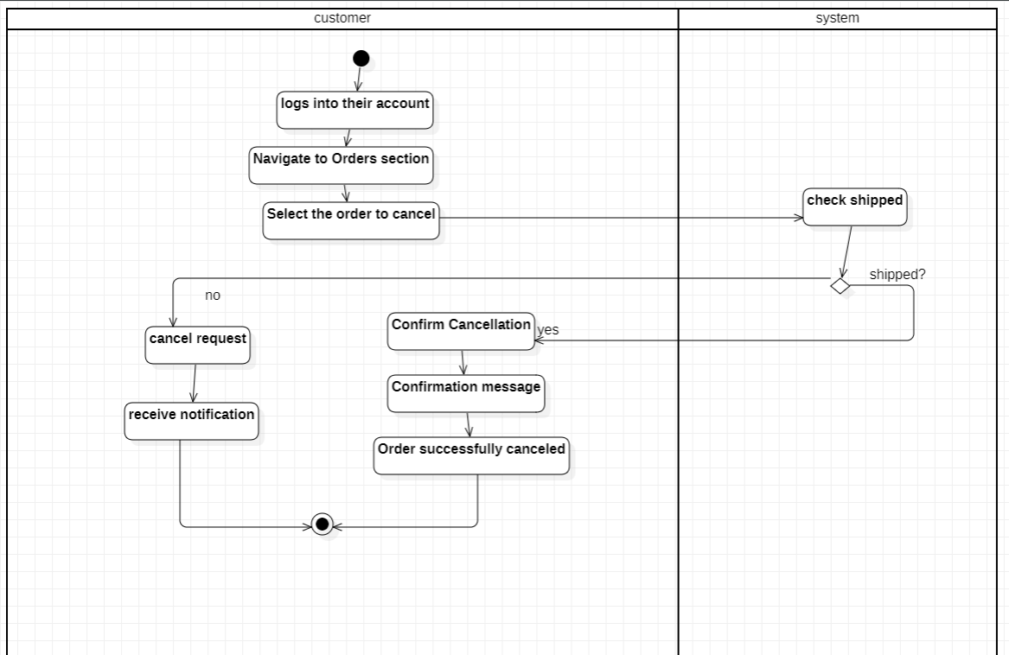
Activity Diagram

Sequence Diagram

  - View Transactions

Title | View Transaction
Actors | Customer
Goal | Enable customers to view past and recent transactions on the website.
Preconditions | - The customer is logged into their account.  - The customer has a transaction history.
Postconditions | The customer successfully views past and recent transactions.
Exceptions | 1. System Error:  - If there's an issue retrieving transactions, the system displays an error message.
Flow of Activity | Actor  - Log In:  The customer logs into their account.  - Navigate to Transactions: The customer clicks on the "Transactions" section.  - View Transaction:  The customer reviews the detailed transaction information.  - Download Receipt :  The customer clicks "Download Receipt" for a specific transaction (if needed). | System  - The system authenticates the customer.  - Provides access to their account.  - showing details such as item names, quantities, prices, and total cost.  - The system displays transaction details, including order date, purchased items, total amount, payment status, and shipping details.  - The system generates and downloads the receipt for the selected transaction.

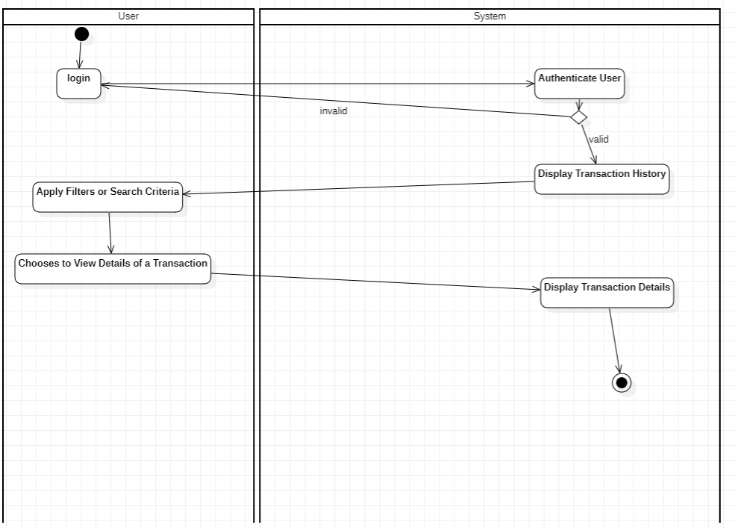
Activity Diagram

Sequence Diagram

Non-Functional Requirements

Usability:
The application should be user-friendly and intuitive for both caregivers and doctors to use.

Reliability:
Having a good backend using Firebase we will have 99.95% uptime.

Maintainability:
Our team will consistently test the app and fix any bugs (if found) ASAP.

Scalability:
The App will be developed by adding new features.

Security:
By using Firebase security metrics (App check) the data of our user “doctors or caregivers and their chats” should be protected from any malicious attack and protect patient privacy by complying with medical regulations and standards.

Performance:
The project should have a fast response time and run smoothly & efficiently.

Compatibility:
The application should be working on old and new android (Android 9.0+) and IOS smartphones (IOS 15.0+)

